

|  |
| --- |
| Web Trade  User Guide |
|  |
| Dave Pert |

# Table of Contents

Introduction

Site Homepage

Using the site to view a product

Group Selection

Compare

Filtering

Product Selection

Previous Parts

Basket Import

Order

Menu Options

My Invoices

My Payments

My VRM History

My Orders

My Account

# Version History

|  |  |  |  |
| --- | --- | --- | --- |
| Version | Date | Who | Comments |
| 0.1 | 5/01/15 | Dave Pert | Initial Draft Document |
| 0.2 | 12/03/15 | Dave Pert | Update with Version 2 features. |
| 0.3 | 10/03/17 | Dan Church | Update with Version 3 features. |

# Introduction

The purpose of this document is to describe the features within the Web Trade product.

# Site Homepage

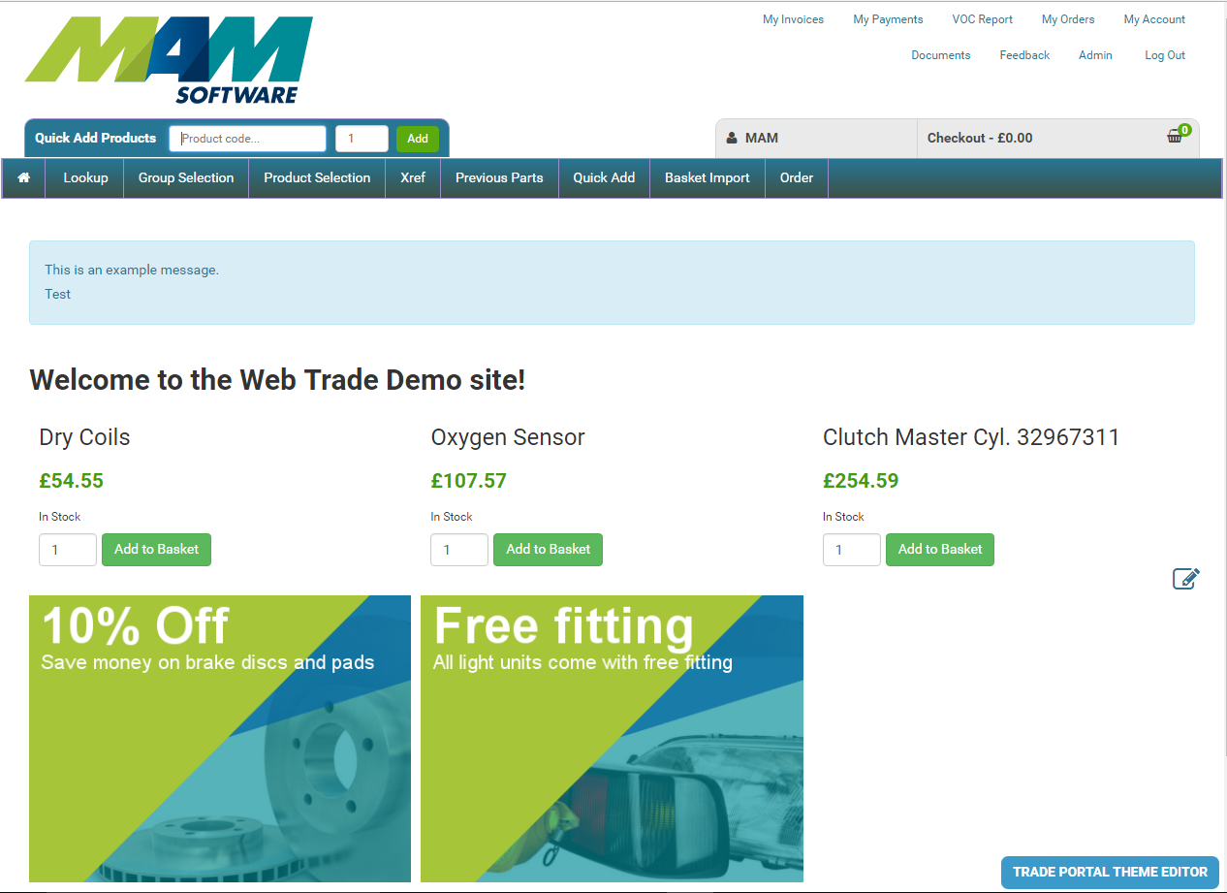

This page can be modified by the site administrator by following the instructions later in the document.

# Using the site to view a product

## Group Selection

To view a product the user must first choose ‘Group Selection’. This will open the page below and allow the user to;

1. Pick the vehicle they are searching parts for.

2. Pick the category groups they want to search in for products.

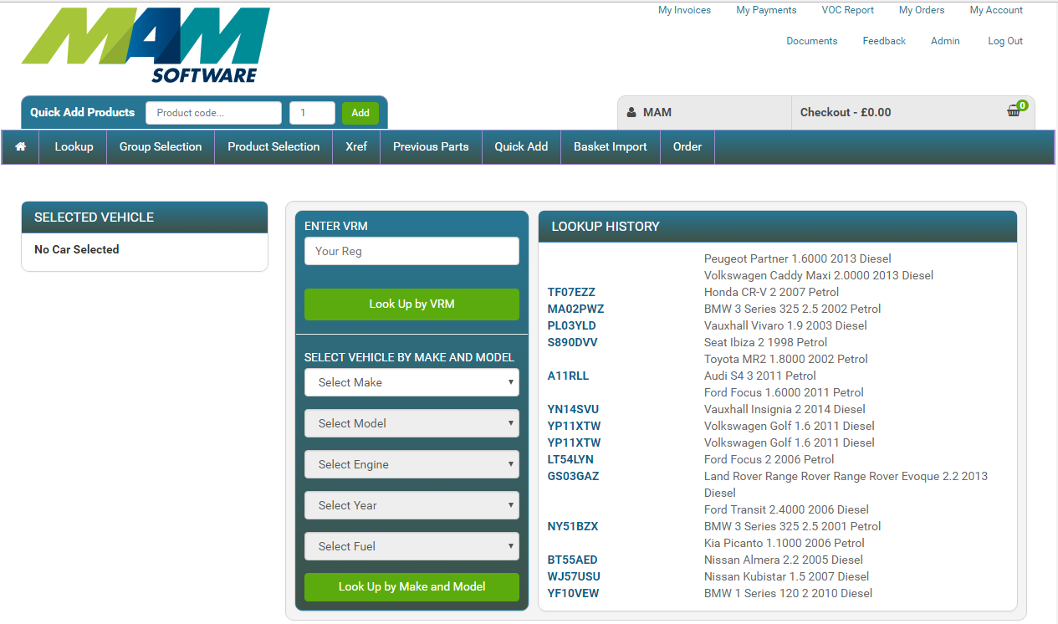

The user can enter a VRM, find a vehicle by make and model or pick a vehicle from a recently used list.

When a vehicle is selected the category groups will be shown as below.

The user should pick from the parent group to view the sub groups. Select the sub groups required and click the ‘Add Selected Groups’ button to add them to a short list of selected category groups to search. When the user has selected the required groups the ‘Find Products’ button should be clicked to start the product search.

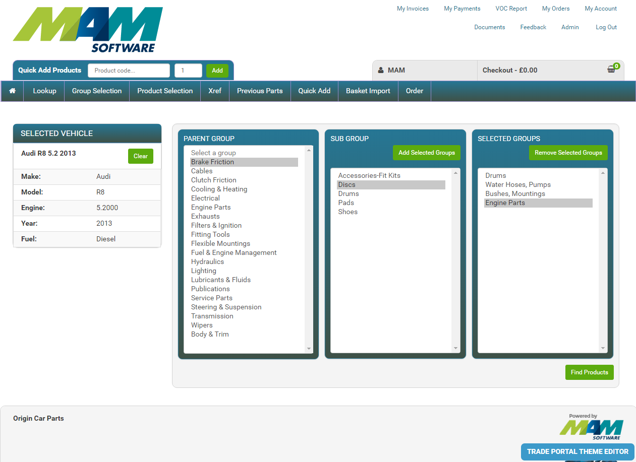

The product results will appear in the results page as below.

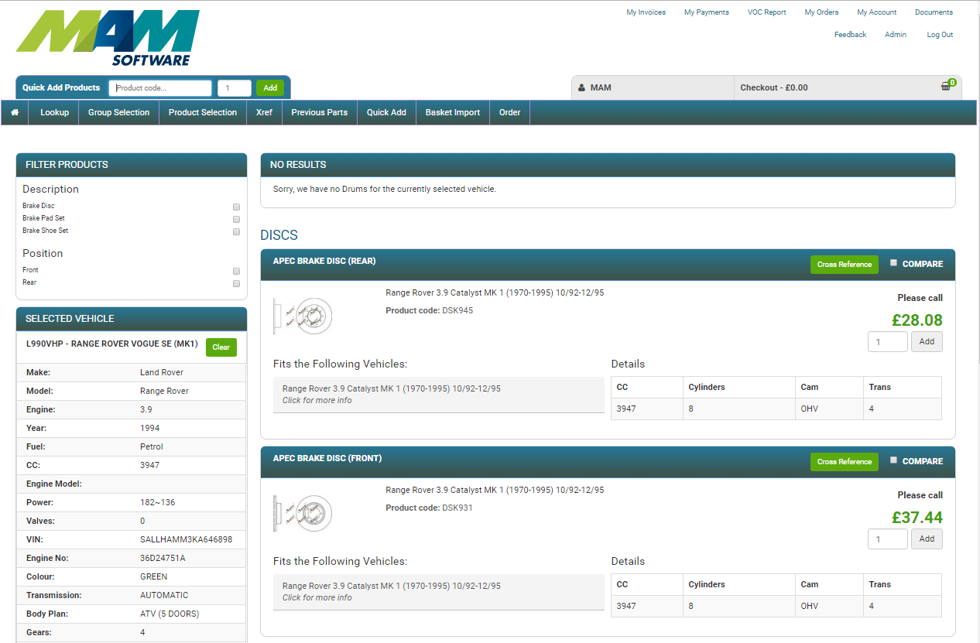

MMI matches are displayed with a green highlight.

Use the Add button to add the product to the basket and start the order creation process.

### Compare

Use the Compare check box at the top right of each product title to mark the products for comparison. When two or more products have been selected a Compare Items button will appear at the top of the page. Click this to open the comparison window.

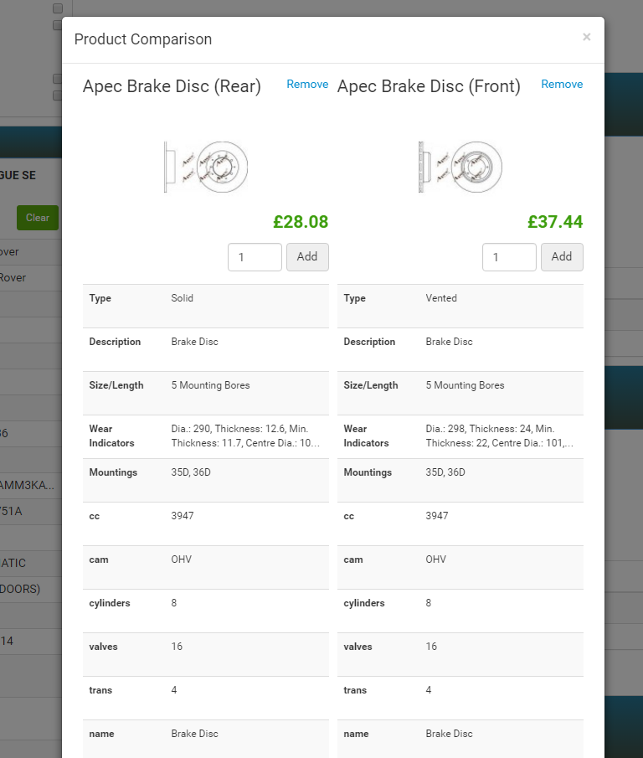

### Filtering

The product list page can be filtered by available attributes. The filters will appear automatically at the top left of the page. Click a box to only show those items. Clicking a box in the same category will include the items that comply with either filters. Clicking a box in another category will show the items that comply with both filters.

## Product Selection

This link will return you to the results of your last vehicle and category group search.

## Previous Parts

This link will display a list of the parts that have been ordered in the past and allow a quick add to place them into the basket again. This feature will be useful where product codes are known and can be identified without requiring a vehicle search. You can also specify when you bought the part to find products faster

## Basket Import

The user is able to bulk upload a list of products. The user must use a .csv file and list the required products and their quantity. The web page will allow the user to select the file for upload, click Choose File. With the file selected the user should click Submit to start the import. The results will be displayed as below.

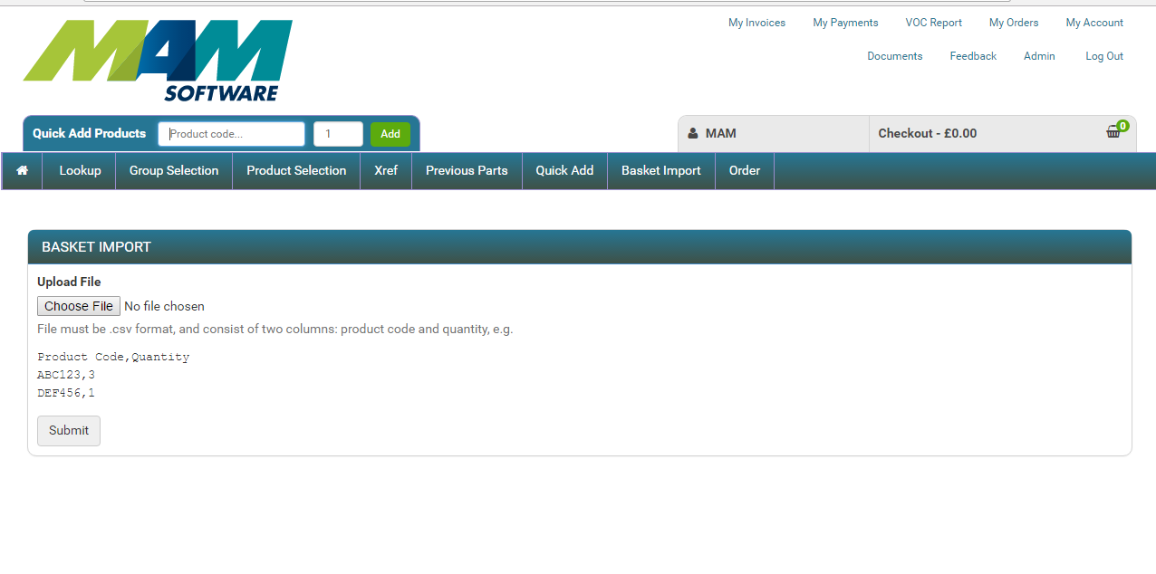

The user may now go to the basket, by clicking Checkout, to view the products that were just uploaded.

## Order

This link will take you to the basket page. The basket page can also be accessed at any time by pressing the ‘Checkout’ button at the top of the page.

When a user adds a product to their basket they will be taken to the basket screen as below.

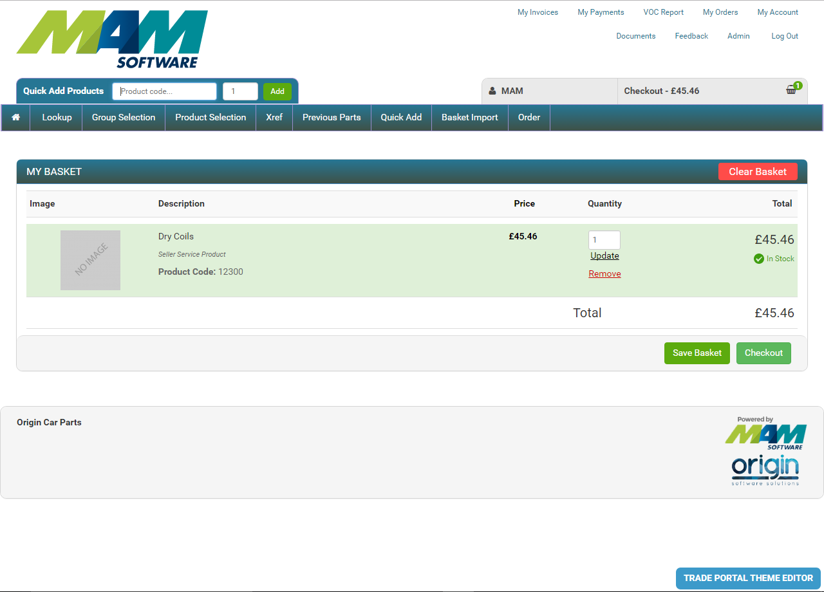

The Checkout button will disappear and a message will be highlighted if there is a problem with the basket.

If the user wants to go back and search for more products they can click the ‘Continue Shopping’ basket to return to the previous page or click ‘Group Selection’ to start a new car or category group search or if they wish to save the current item in the basket to purchase again, you can click the Save Basket button to do so.

The user can use the Quick Add feature of the site by entering a product code into the quick add text box. This is useful if the product code is known.

Clicking ‘Checkout will create an order from the items in the basket.

# Menu Options

## My Invoices

This link will display a summary of available invoices.

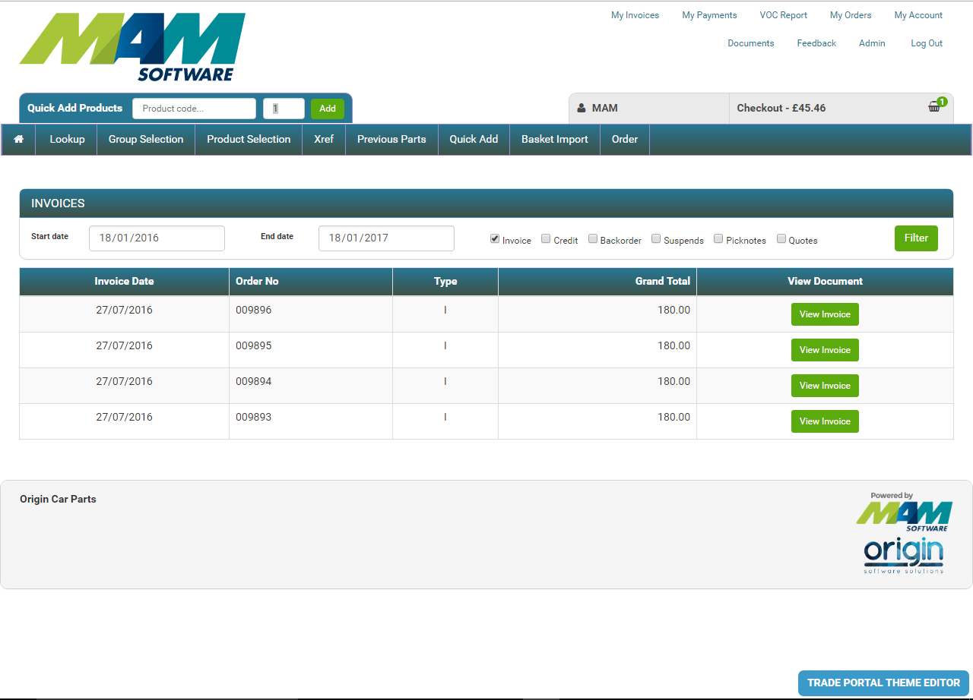

Clicking on the ‘View Invoice’ button will display the full detail of the invoice.

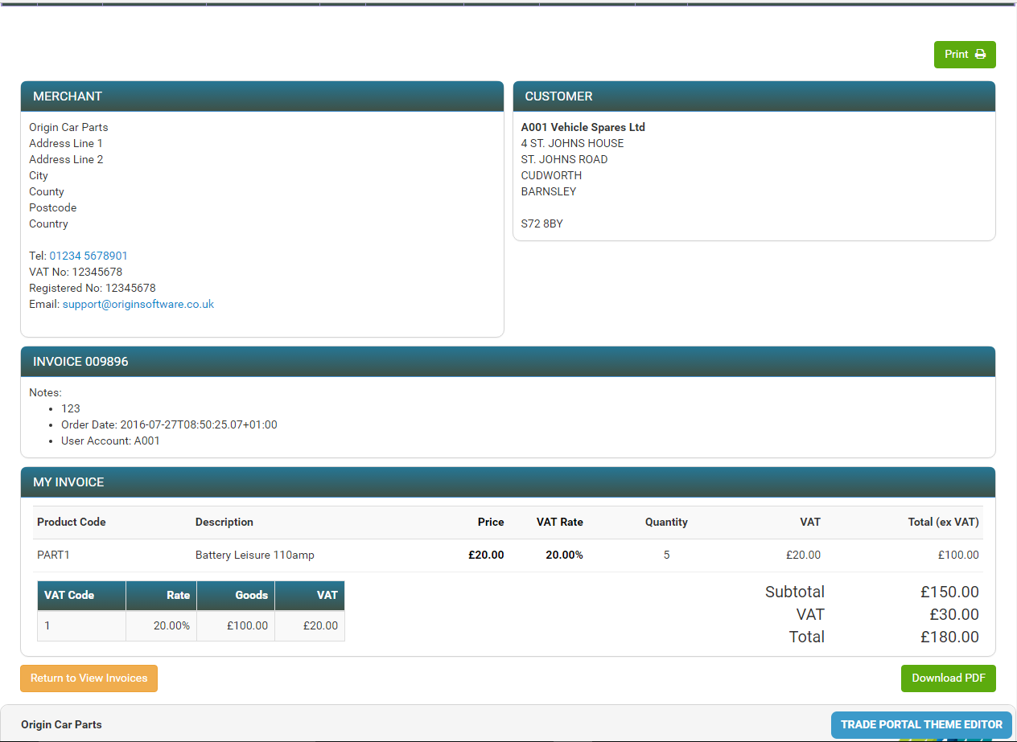

## My Payments

This link will display a summary of the payments made on the account.

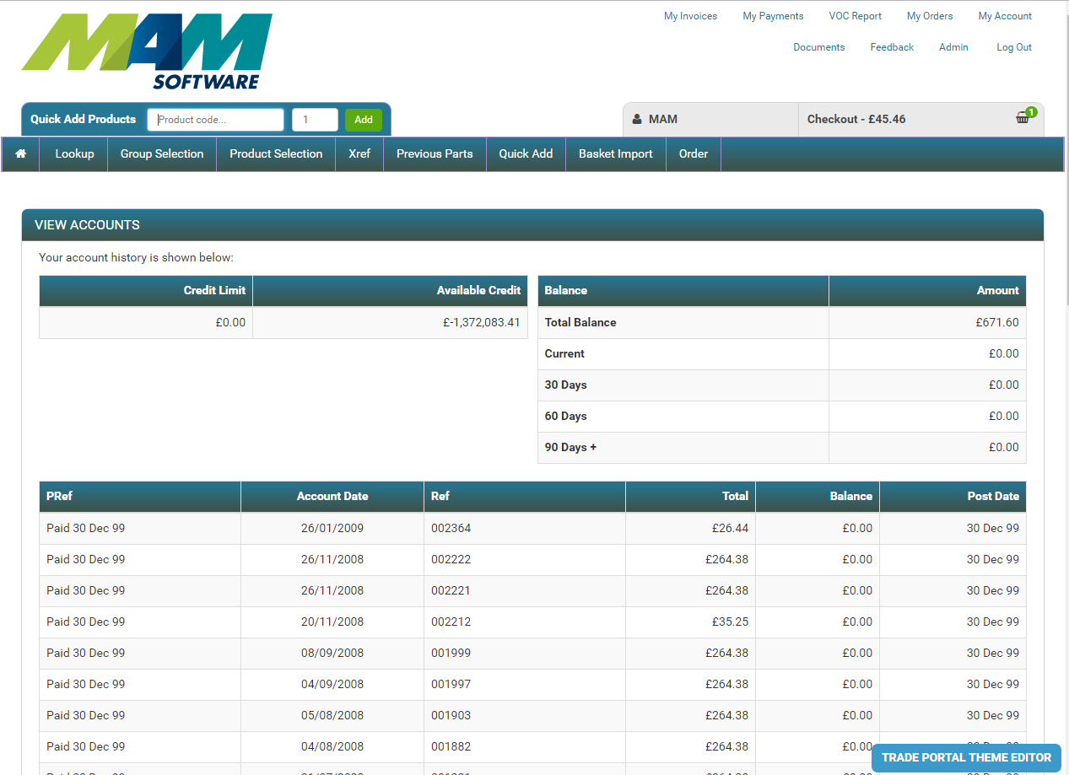

## My VRM History

The recent VRM lookup history is available for quick re-use by going to Lookup and the History will be on the right of the screen. The summary will be displayed as below.

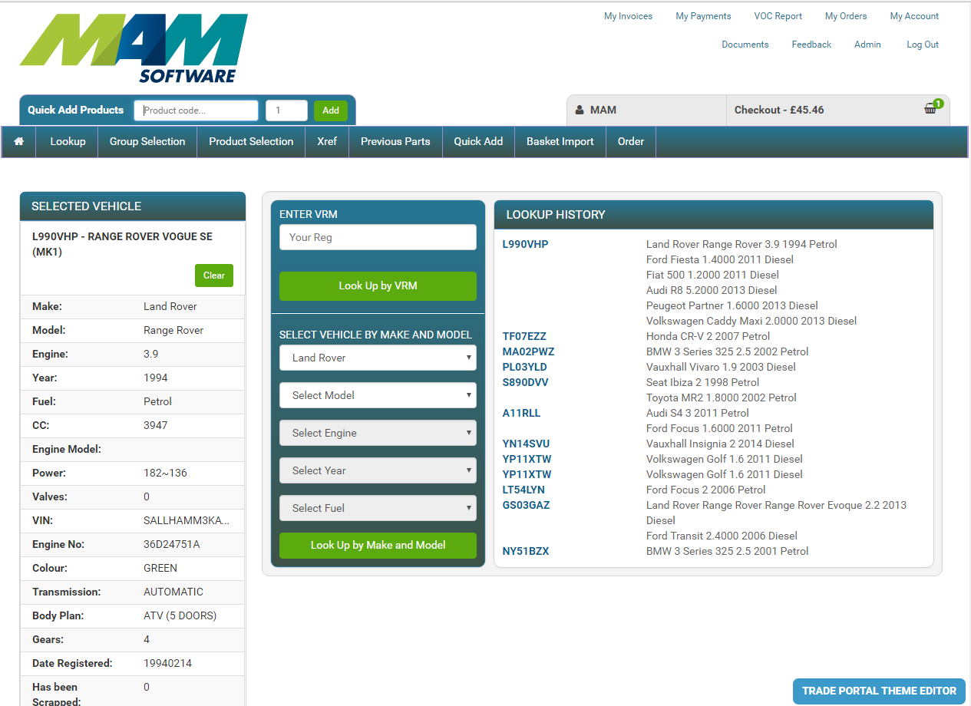

## My Orders

This link will display a summary of the orders made on the account.

## My Account

This link will display the user’s details and, if the setting has been enabled in the admin area, the users address details. Addresses are maintained by the administrator (only) if they are not displayed to the user here. The user password can be changed from here.

